Practical : 2

## Aim: Develop simple application using .net facility

Login.aspx

<%@ Page Language="vb" AutoEventWireup="false" CodeBehind="Login.aspx.vb" Inherits="Practical_2.Login" %>

<!DOCTYPE html>

<html xmlns="http://www.w3.org/1999/xhtml">

<head runat="server">

<title></title>

</head>

<body>

<form id="form1" runat="server">

<div>

Username :

<asp:TextBox ID="TextBox1" runat="server"></asp:TextBox>

<br />

Password :

<asp:TextBox ID="TextBox2" runat="server" TextMode="Password"></asp:TextBox>

<br />

<br />

<asp:Button ID="Button1" runat="server" Text="Login" />

</div>

</form>

</body>

</html>

Login.aspx.vb

Public Class Login

Inherits System.Web.UI.Page

Protected Sub Page_Load(ByVal sender As Object, ByVal e As System.EventArgs) Handles Me.Load

End Sub

Protected Sub Button1_Click(sender As Object, e As EventArgs) Handles Button1.Click

Response.Redirect("Home.aspx")

End Sub

End Class

Home.aspx

<%@ Page Language="vb" AutoEventWireup="false" CodeBehind="Home.aspx.vb" Inherits="Practical_2.Home" %>

<!DOCTYPE html>

<html xmlns="http://www.w3.org/1999/xhtml">

<head runat="server">

<title></title>

</head>

<body>

<form id="form1" runat="server">

<div>

Welcome to Ishan's Website

<asp:Button ID="btnURL" runat="server" Text="Log Out" />

<br />

<br />

Enter Your Birth Year :

<asp:Button ID="calVisible" runat="server" Text="..." />

<asp:Calendar ID="cal" runat="server" visible="false" />

<br />

<asp:Button ID="btnSubmit" runat="server" Text="Submit" />

</div>

</form>

</body>

</html>

[Home.aspx.vb](http://Home.aspx.vb)

Public Class Home

Inherits System.Web.UI.Page

Protected Sub Page_Load(ByVal sender As Object, ByVal e As System.EventArgs) Handles Me.Load

End Sub

Protected Sub calVisible_Click(sender As Object, e As EventArgs) Handles calVisible.Click

cal.Visible = True

End Sub

Protected Sub btnURL_Click(sender As Object, e As EventArgs) Handles btnURL.Click

Response.Redirect("Login.aspx")

End Sub

End Class

Output :

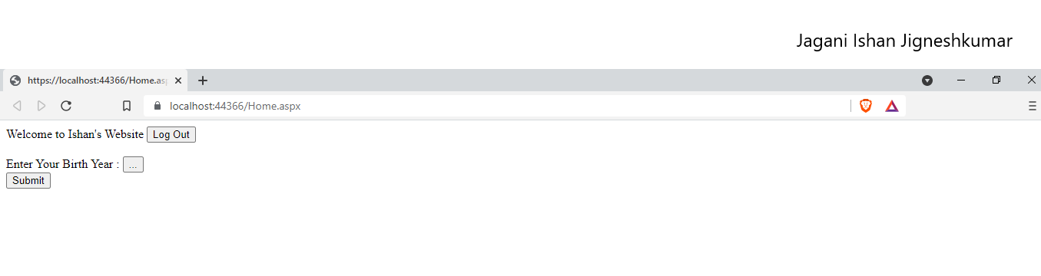

On Pressing Log Out Button :

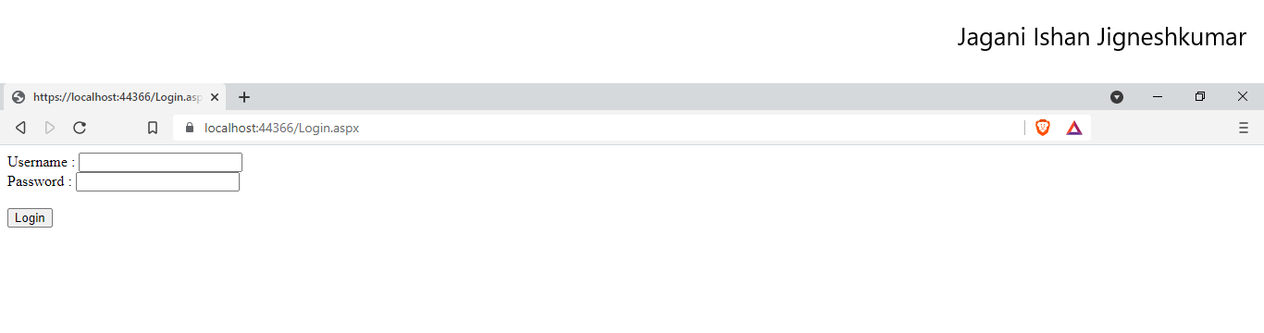

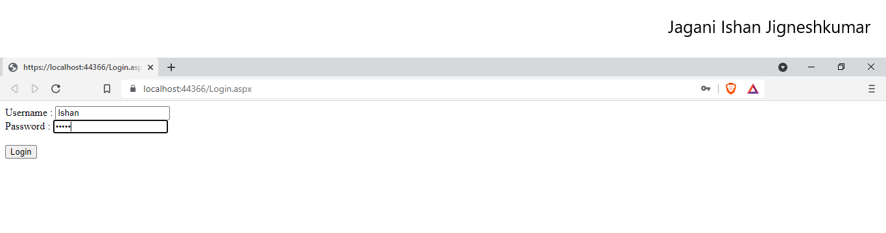

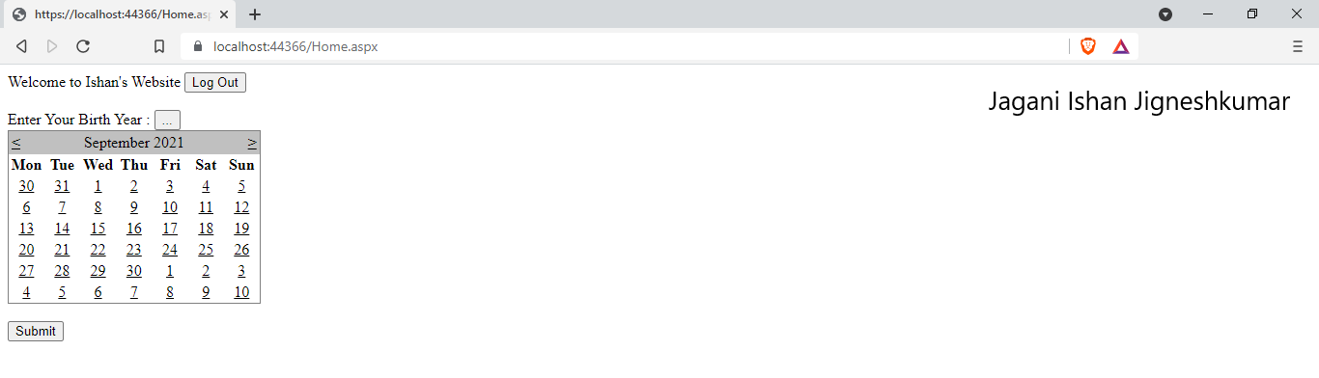

|  |  |  |  |
| --- | --- | --- | --- |
| Start Date | End/Sign Date | Faculty Sign | Remarks/Grade |
|  |  |  |  |